From Martin Luther’s 1528 Confession of Faith

Nor do we find anything in the Scriptures about purgatory; this, too, of course, is an invention of ghosts or sprites; therefore I hold that it is not necessary to believe in it, although with God all things are possible and He could also permit the soul to be tormented after it leaves the body. But He did not reveal anything about this; therefore He does not want us to believe it. But I know of another purgatory, of which, however, we are not to teach anything in the congregation, and against which nothing is to be accomplished by institutions or vigils.
As to the invocation of saints, others have opposed this before I did; and I am pleased to believe that Christ alone is to be called upon as our Mediator; the Scriptures teach this and it is true. The Scriptures teach nothing about the invocation of saints, therefore it is uncertain and can not be relied on.
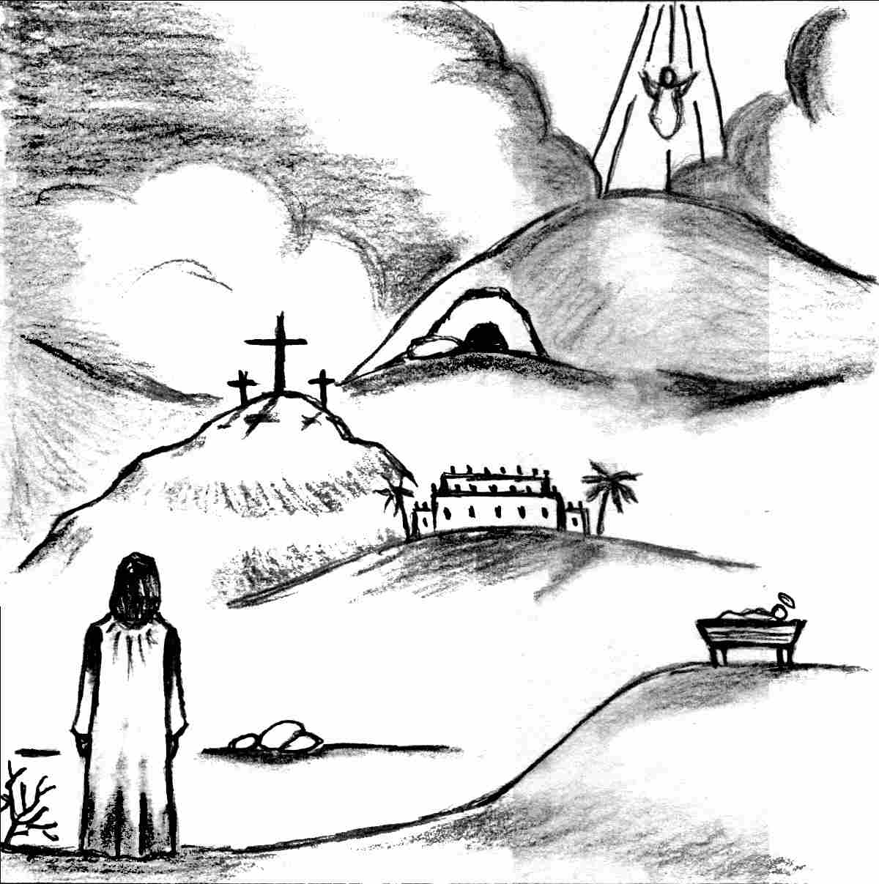
... he departed from Him
until an opportune time
Our Redeemer Lutheran Church
403 South Hayes
Emmett, Idaho 83617 Church: 208-365-5231

Pastor: Rev. Michael L. McCoy
parsonage: 208-365-5214
email: mmccoy19@earthlink.net
www.scholia.net – the website for:
Good News for the Diaspora!
scholia.net publishing – Where the Word is not Bound
Predici in limba romana – (Sermons in Romanian)
The artwork is by Sharon Geiser. Permission to use this copyrighted graphic is limited to congregational use. Martin Luther’s 1528 confession of faith is from The Distinctive Doctrines of the Different Christian Confessions in the Light of the Word of God by Karl Graul (1814-1864). The 1897 English translation by D. M. Martens is in the public domain. The full text of Luther’s confession may be downloaded at the website below.

This bulletin cover provided by www.scholia.net and is made available without cost.

29 February Anno Domini 2004

Lent 1

To place the graphic on this page:
Copy the graphic on the previous page.
Click on the open space above and a graphic box should appear. Paste the graphic.

Change this frame and the box above by clicking the body of the text and adding the particulars. (See the previous page for an example.)
The artwork is by Sharon Geiser. Permission to use this copyrighted graphic is limited to congregational use. Martin Luther’s 1528 confession of faith is from The Distinctive Doctrines of the Different Christian Confessions in the Light of the Word of God by Karl Graul (1814-1864). The 1897 English translation by D. M. Martens is in the public domain. The full text of Luther’s confession may be downloaded at the website below.

This bulletin cover provided by www.scholia.net and is made available without cost.

29 February Anno Domini 2004
Lent 1
... he departed from Him
until an opportune time

From Martin Luther’s 1528 Confession of Faith

Nor do we find anything in the Scriptures about purgatory; this, too, of course, is an invention of ghosts or sprites; therefore I hold that it is not necessary to believe in it, although with God all things are possible and He could also permit the soul to be tormented after it leaves the body. But He did not reveal anything about this; therefore He does not want us to believe it. But I know of another purgatory, of which, however, we are not to teach anything in the congregation, and against which nothing is to be accomplished by institutions or vigils.
As to the invocation of saints, others have opposed this before I did; and I am pleased to believe that Christ alone is to be called upon as our Mediator; the Scriptures teach this and it is true. The Scriptures teach nothing about the invocation of saints, therefore it is uncertain and can not be relied on.

